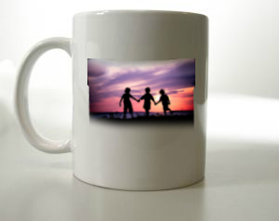
Sometimes it’s nice to share photos among friends and family online.

However, sometimes it’s nice to buy photo gifts (e.g. a mug, t-shirt or book with photos printed on it).
Code 1
- Follow QR Code 1 to see a list of photo gift sites. Explore some of them and see what gifts can be ordered but don’t enter any payment details unless you trust the site and actually want to buy something

There are other things you can do with photos online. For example, you can put a photo of your face into a video to make a fun online card to send to friends.

- Follow QR Code 2 to ‘JibJab’. You will need a ‘head and shoulders’ photo of yourself to try this. Pick a card you would like to send and upload the picture of yourself to make card. Remember not to enter any payment information so that you only use the free cards
Code 2

